WHAT’S NEW

Wasatch Front Travel Demand Model

Version 9.0.1

WFRC / MAG

June 24, 2024

Table of Contents

1 Overview 1

2 Changes To Input Files 2

2.1 Traffic Analysis Zone 2

2.1.1 Changes to TAZ Attributes 2

2.1.2 Rename TAZ Shapefile 3

2.2 Highway Network 3

2.2.1 Network Changes Due to Segment Shapefile Updates 3

2.2.2 General Maintenance & Corrections 4

2.2.3 Rename Master Network 7

2.3 Transit Networks 7

2.3.1 Changes to Transit Line Files 7

2.4 Segment Shapefile 7

2.4.1 Changes to Segment Attributes and Geometry 7

2.4.2 Renamed Segment Shapefile 9

2.4.3 Added “_Segment Processing Tools” Folder 9

3 Model Enhancements 10

3.1 Miscellaneous Script Edits & Bug Fixes 10

3.1.1 “0_InputProcessing” 10

3.1.2 “3_Distribute” 10

3.1.3 “4_ModeChoice” 11

3.1.4 “5_AssignHwy” 11

3.1.5 “Scenarios\_default” 12

4 v901-patch1 Update (2024-04-30) 13

4.1 Changes to Input Files 13

5 v901-patch2 Update (2024-06-24) 14

5.1 Changes to Input Files 14

List of Figures

Figure 2.1 TAZs with Undevelopable Acres 2

Figure 2.2 New Highway Nodes & Links (blue) 6

Figure 2.3 Highway Links with New or Adjusted SEGID Value (blue) 8

List of Tables

Table 2.1 Percentage of SEGID Changes by County 7

# Overview

Version 9.0.1 is a minor update to the Wasatch Front Travel Demand Model. The model processes and parameters are the same as version 9.0.0. Minor changes were made to a few of the primary input files and to the model scripts. These changes were primarily to fix issues in data and calculations or to further enhance the model’s capability or reporting. It is not anticipated that the changes made to the model would affect project decisions. However, model users should verify this for individual projects.

Changes to the model inputs in version 9.0.1 include minor updates made to the TAZ shapefile and transit networks. More significant updates were made to the highway network and segment shapefile. The updates to the highway network include changing the network geometry and link/node structure to align with the updated planning segments, correcting issues in project coding and zone connection, and general maintenance. The updates to the segment shapefile include additional segments, deleted segments, field reordering, and various segment realignments. Because of the large number of edits made to the highway network link/node structure and to the segment shapefile, network and segment related reporting in version 9.0.1 are not backward compatible with version 9.0.0.

Changes made to the model scripts in version 9.0.1 include edits for minor issue resolution, file renaming, and various cleanup items meant to improve the model’s capability and cleanliness.

# Changes To Input Files

## Traffic Analysis Zone

### Changes to TAZ Attributes

The following attributes in the TAZ shapefile were updated (note, TAZ geometry and numbering were unchanged).

**City Name**

* The value “Mill Creek” was replaced with “Millcreek” in the **CITY_NAME** field
* The **CITY_UGRC** and**CITY_FIPS** fields were updated to be consistent with **CITY_NAME**
* A new City district shapefile was created based on updated the city name and ID fields

**Developable Acres**

* [The](https://github.com/WFRCAnalytics/WF-TDM-v9x/issues/14) **DEVACRES** and **DEVPBLEPCT** fields were set to 0 in TAZs with no developable land. A new point shapefile, “*undevelopable-points_WF.shp”,* was added to the “*1_Inputs\1_TAZ\_Source\EnvConstraints*” folder to keep track of these override undevelopable TAZs. Figure 2.1 shows which TAZs had their fields set to 0.

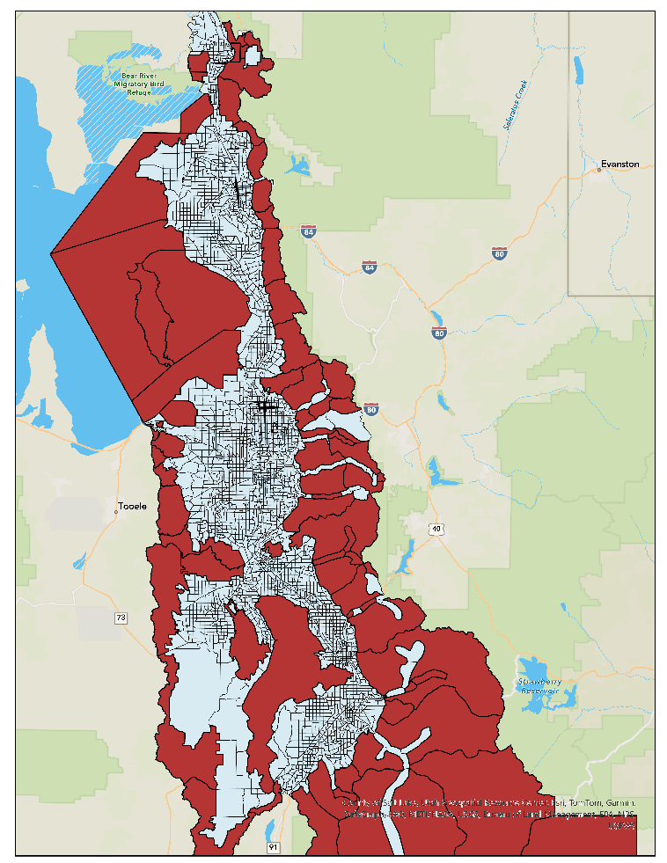

Figure 2.1 TAZs with Undevelopable Acres

### Rename TAZ Shapefile

The TAZ shapefile was renamed from “*TAZ.shp”* to “*WFv901_TAZ_{date-stamp}.shp”* to comply with the new model file naming convention determined by the Interagency Modeling Technical Committee (IMTC). The **TAZ_DBF** variable was updated in the “*Scenarios\_default\ControlCenter.block*” files.

## Highway Network

### Network Changes Due to Segment Shapefile Updates

The highway network was updated to coincide with the updates made to the segment shapefile (see the Segment Shapefile section of this report). Primarily, these changes consisted of adding nodes, splitting links, and updating the **SEGID** link field. However, a few new corridors were added to the network and some link/nodes positions were changed to better align with the segment shapefile. The edits made to the network node and link geometry to accommodate desired segment updates constitute the vast majority of the geometric changes made to the network in version 9.0.1. Because of the large number of edits made to the highway link-node structure, the version 9.0.1 highway network is not backward compatible with version 9.0.0 highway network.

The complexity of the frontage road system in the highway network in future scenarios caused the value in the **SEGID** field to not be unique for all scenarios. To allow for a link’s SEGID to change between scenarios, a set of SEGID exception fields were added to the Master Network. When SEGID changes in a scenario, the new SEGID is coded into the scenario’s corresponding SEGID exception field. This will trigger an override of the SEGID calculation in the network processor script. Blank values use the primary SEGID field, i.e. no override. The field names for the SEGID exception field set follow the naming convention used for the lane and functional type field set:

* Base and TIP years
  + SGX_2019
  + SGX_2023
  + SGX_2028
* Fiscally Constrained Plan years
  + SGX23_32
  + SGX23_42
  + SGX23_50
* Unfunded Need Plan years
  + SGX23_32UF
  + SGX23_42UF
  + SGX23_50UF

A new variable, **SegIdExField**, was added to the “*1ControlCenter.block*” file to select which SEGID exception field to use in the scenario.

### General Maintenance & Corrections

Clean up work was done to the highway network to fix errors or to do general maintenance. Below is a list of specific changes made to the highway network. Note that the project list coded into the v9.0.1 highway network represents the Regional Transportation Plans adopted May 2023.

Nodes

* **MAG_NODE** field was corrected for 16 nodes
* **GEOGKEY** field was corrected in 10 instances
* The **PNR** fields were updated for two nodes at the Tooele express bus park and ride location where PNR values were set to 0.

Links

* Updated connections to TAZ 90 and removed 1500 S in Brigham City between 775 W and Hwy 89 (not yet existing or planned in future phases)
* Connected 4600 S from Harrison Blvd to Skyline Drive south of Weber St Campus
* Updated connection for West Weber Corridor to Hwy 89 and corrected some centroid connections
* Removed Arsenal Rd in HAFB from 2015-2028 and left connections in TAZs 647, 632, and 655 to the base to the east only
* Updated I-15 Northbound from Park Ln to 200 N to reflect 4 lanes
* Updated West Davis/West Weber corridor north of SR 193 to a functional type of 12
* Fixed Shephard Ln disconnect
* Turned off link for 400 N / North St where it does not yet cross the rail tracks
* Removed floating link on 700 S just west of 3000 W in West Pointe
* Updated 4700 S westbound from 4000 W to 4800 to reflect 2 lanes
* Adjusted the 7400 South from Oquirrh Blvd to MVC RTP Project to be a grade separated crossing at MVC instead of at-grade
* Turned on Herriman Phase 1 project at Silver Sky Dr
* Added in 520 W (Seg ID 3440_005.8) between 400 N and 2nd St
* Added in 3200 W from 2100 N to 3500 N and 3500 N from 3200 W to 2200 W (Scannell Swaner development)
* Added in 4420 W between 4700 W and 5400 S (used Seg ID from UDOT)
* Turned on links for 3800 S between 220 W and 1700 W
* Added in 3785 S between 6400 W and 7200 W
* Added in 6000 W between 3500 S and 4100 S
* Removed local connection between 11800 S and Lake Ave at MVC
* Removed local connection between 14600 S and 14400 S at Redwood Rd
* Aligned Doubleday and Sunrise Ranch in Mapleton with existing roads
* Turned on Ring Road links in Saratoga Springs to match existing conditions
* Turned off 2023 road between Pony Express Parkway and Temple Area (non-foothill)
* Fixed network in Saratoga and Eagle Mountain to match existing roadway network
* Extended Foothill frontage roads down to Lariat Blvd in Saratoga Springs
* Turned on Sunset Drive in Eagle Mountain for 2019, 2023, and 2028
* Turned on Mt Airey Drive in Eagle Mountain for 2019, 2023, and 2028
* Fixed centroid connection to TAZs 42, 260, 1992, 1993, 2005, and 2006 and edited other centroid connectors to fix unconnected zones
* Connected centroid to TAZ 931 to unfunded network
* Realigned links and added links based on UDOT LRS updates on the following corridors:
  + 500 W / 3700 W between Bluff Ridge Blvd and Antelope Dr
  + Station Pkwy / Burke Ln between 1525 W and Park Ln
  + 1525 W between Station Pkwy / Burke Ln and Clark Ln
  + North Frontage Rd / 8000 W / 1400 N between 7200 W and Utah State Prison and Correctional Facility
  + Gordon Ave
  + Cherry Ln
  + 13200 S between 1300 W and Highland
  + Herriman Main St
  + Porter Rockwell Blvd
  + Layton Pkwy
  + Hill Field Rd
  + 2700 W between WDC and Hill Field Rd
  + 2200 W between Layton Pkwy and 700 S
  + 1800 S to 2100 S Connector between SR-126 and 2700 W
  + 3600 S to 3300 S Connector between 2700 W and 3600 W
  + Depot St between 700 S and 1000 E
  + Shadow Valley between SR-203 and Skyline Pkwy
  + Frontage Rd between Shepard Ln and Burton Ln
  + Petunia Wy, 9800 S, 17000 E collector roads between 9400 S and Sego Lily Dr and 1300 E and Eastdell Dr
  + Lincoln Ln and 2000 E collector roads between Highland Dr and 2700 E and 3900 S and 4500 S
* Fixed **HOT23_32** through **HOT23_50UF** fields to correctly reflect the RTP projects from Farmington to the Utah/Salt Lake County line

Between the edits made to the highway network for the segment shapefile update and the general network maintenance, approximately 150 nodes and 900 links were added to the highway network in version 9.0.1, the bulk of which occurred in Saratoga Springs, Eagle Mountain, Weber County, Holladay, Sandy, and Draper. Figure 2.2 highlights the locations of the new nodes and links added to the version 9.0.1network.

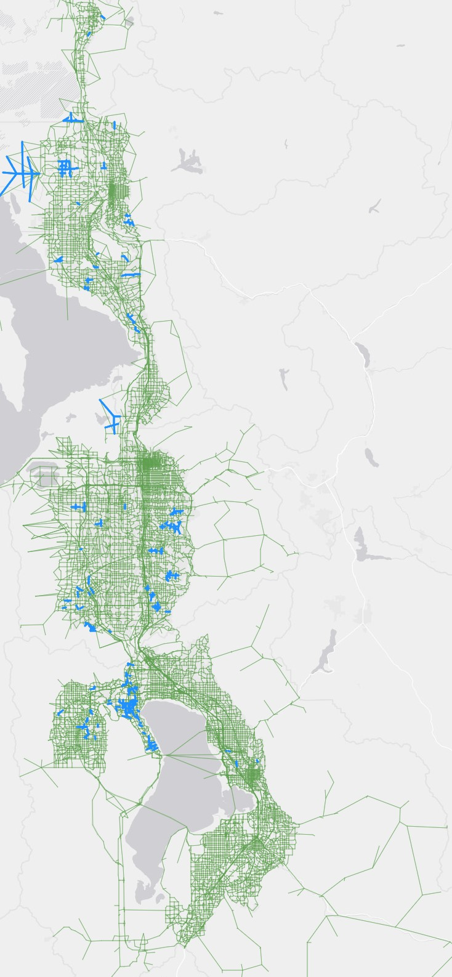

Links

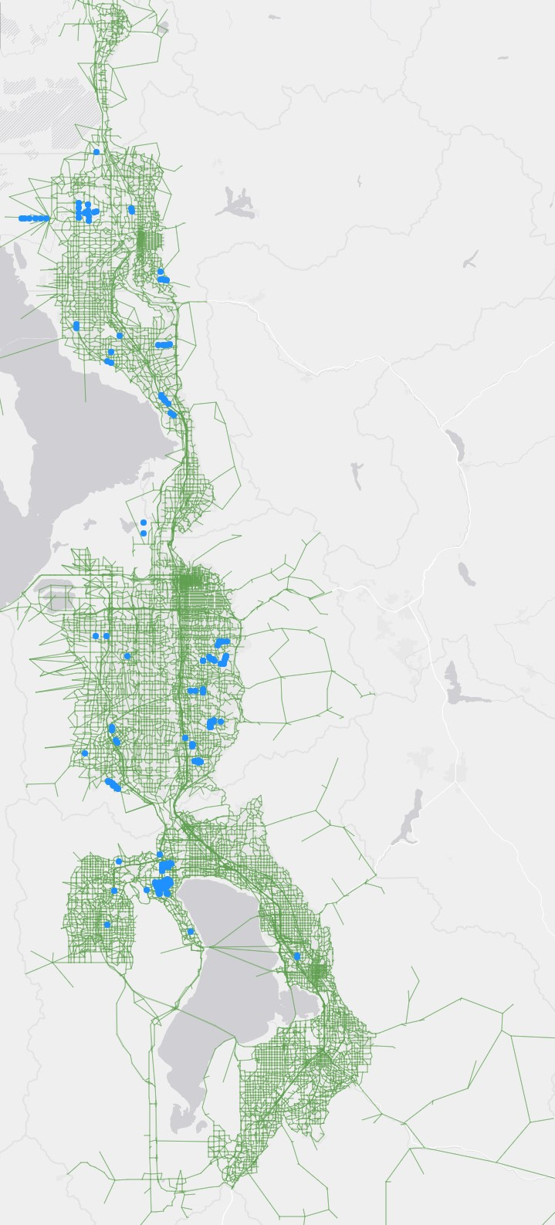

Nodes

Figure 2.2 New Highway Nodes & Links (blue)

### Rename Master Network

The master network was renamed from “*MasterNet_v9 – {date-stamp}.net”* to “*WFv901_MasterNet_{date-stamp}.net”* to comply with the new model file naming convention determined by the Interagency Modeling Technical Committee (IMTC). The **MasterPrefix** variable was updated in the “*Scenarios\_default\ControlCenter.block*” files.

## Transit Networks

### Changes to Transit Line Files

The changes made to the transit line files were to make the line files compatible with the highway network geometry edits, primarily where links were split along a transit route. The project list coded into the v9.0.1 transit network represents the Regional Transportation Plans adopted May 2023.

## Segment Shapefile

### Changes to Segment Attributes and Geometry

The segment shapefile was updated extensively to allow for future segment-level processing of the transit results, to develop a more accurate [traffic volume forecast](https://unifiedplan.org/traffic-volume-map/), and to correct for compatibility issues with the highway network. Hundreds of new segments were added and many were deleted or adjusted to better reflect the current and future physical roadway. Because of the large number of edits made to the segments, the segment shapefile and any segment reporting in version 9.0.1 are not backward compatible with version 9.0.0.

Overall, there were approximately 5000 changes to the **SEGID** value between version 9.0.0 and version 9.0.1. This includes the addition of around 3000 new SEGID values and the renaming of around 2000 SEGID values. SEGID shapefile edits were also reflected in the highway network. Table 2.1 gives the percentage of SEGID changes by county. The majority of SEGID updates occurred in Utah County followed by Salt Lake County.

Table 2.1 Percentage of SEGID Changes by County

|  |  |
| --- | --- |
| County | Change in SEGID |
| Box Elder | 1% |
| Weber | 3% |
| Davis | 6% |
| Salt Lake | 21% |
| Utah | 69% |

Eagle Mountain saw the most SEGID changes (22%), followed by Saratoga Springs (8%), Santaquin (6%), West Jordan (5%), and Payson (5%).

Figure 2.3 shows where SEGIDs changes occurred between versions 9.0.0 and 9.0.1 in the model network. This provides a representation of where new and adjusted segments are located in segment shapefile.

Figure 2.3 Highway Links with New or Adjusted SEGID Value (blue)

### Renamed Segment Shapefile

The segment shapefile was renamed from “*Segments_WF – {date-stamp}.shp”* to “*WFv901_Segments_{date-stamp}.shp”* to comply with statewide naming standards as determined by the Interagency Modeling Technical Committee (IMTC).

### Added “_Segment Processing Tools” Folder

A new methodology was developed and utilized for updating the segment shapefile. This process is documented in a Jupyter notebook file “*0-How-to-Prep-Segments-for-TDM.ipynb”* located in a new folder “*1_Inputs\6_Segment\_Segment Processing Tools”*. In short, this script outlines five steps to be followed when developing new and updated segments.

1. Ensure consistency between the master network and segment shapefile.
   1. Unique **SEGIDs** in shapefile.
   2. Correct **DISTANCE**.
   3. Correct LRS Segments **BMP**, **EMP**, and **DISTANCE**.
   4. TDM Network includes all **SEGIDs**.
   5. Segment Shapefile includes all **SEGIDs**.
   6. Correct geographic coordinate system.
2. Add Geographic Keys onto Segments (**SUBAREAID**, **PLANAREA, CO_FIPS**).
3. Add AADTs onto Segments.
4. Add Factors from Continuous Count Station groups.
5. Add final forecasts from forecasts process.

This new process ensures the segment shapefile is ready for the traffic volume forecasts map, as well as ensures only the needed and relevant attributes are included.

# Model Enhancements

## Miscellaneous Script Edits & Bug Fixes

The following sections highlight the scripts that were edited in version 9.0.1 and why those edits were made. These changes were primarily to fix issues in data and calculations or to further enhance the model’s capability or reporting. The changes made to the model scripts are minor and should not affect project decisions.

### “0_InputProcessing”

**”a_Setup\1_InputSetup.s”**

* Updated checking code block to look for **SegIdField** and **SegIdExField** variables from control center
* Fixed spelling error in log file reporting

**“c_NetworkProcessing\1_NetProcessor.s”**

* Added code block to use **SegIdField** and **SegIdExField** variables from control center to populate SEGID link field
* Fixed error in operational project capacity calculation to use 10% increase in capacity if **Run_Op_Proj** control center variable is on and the **Op_Proj** link field is greater than zero (previous script used the value in the **Op_Proj** field as a multiplier on capacity)
* Fixed error in the **HOV_LYEAR** usage so calculation is performed on the general purpose links where there is an adjacent HOV/HOT lane (previous script was coded to process HOV/HOT links)
* Miscellaneous edits to clean up script

**“c_NetworkProcessing\4_Create_walk_xfer_access_links.s”**

* Updated code to point to *“@ScenarioDir@0_InputProcessing\UpdatedMasterNet\@MasterPrefix@.net”* instead of master network from the input folder
* Updated code to process only internal zones (i.e. exclude external and dummy zones) to fix an error where walk access links were being generated to external/dummy zones
* Added SEGID, including code to process SEGID exception field, to the rail network export

### “3_Distribute”

**“2_estimateHOTspeedtoll.s”**

* Updated code so period speeds and times are not greater than free flow (some locations in the assigned output networks displayed HOT speeds greater than free flow)
* Rounded free flow and daily speed to 1 decimal and rounded all times to 3 decimals
* Note, similar edits were made in *“5_AssignHwy\04_SummarizeLoadedNetworks.s”*

### “4_ModeChoice”

**“11-13_MC_HBW_HBO_NHB_HBC.s”**

* Appended the content of *“13_DailyModeSplit.s”* script to the end of *“11_12_MC_HBW_HBO_NHB_HBC.s”* script
* Renamed *“11_12_MC_HBW_HBO_NHB_HBC.s”* script to *“11-13_MC_HBW_HBO_NHB_HBC.s”*
* Deleted *“13_DailyModeSplit.s”*
* Updated script references in *“_HailMary.s”*, *“__HailMary_1Subfolder.s”*, and *“__HailMary_2Subfolders.s”* in the *“Scenarios\_default”* folder

### “5_AssignHwy”

**“02_Assign_AM_MD_PM_EV.s” and “04_SummarizeLoadedNetworks.s”**

* Scripts were updated to create additional select link summary statistics and to provide enhanced reporting
* Select link information are reported for a summary of trip purposes and vehicle classes and time period
* Like other select link data, new select link files are only created if the **Use_SelLinkGrp** parameter in the control center is set to 1
* *“02_Assign_AM_MD_PM_EV.s”* edits:
  + Added code to output daily origin-destination (OD) vehicle trip matrices
  + Added code to create a new report, *“@unloadednetprefix@_SL_Summary.csv”* located in the scenario *“5_AssignHwy\3_SelectLink”* folder, that lists row and column sums from the period OD vehicle trips
* *“04_SummarizeLoadedNetworks.s”*
  + Added code to create two new networks, *“@unloadednetprefix@__SL_TotVolume.net”* and *“@unloadednetprefix@__SL_MaxVolume.net”* located in the scenario *“_AssignHwy\2a_Networks”* folder:
    - *“SL_TotVolume.net”* – shows the percentage of select link volume of each link to total roadway volume of each link
    - *“SL_MaxVolume.net”* – shows the percent of select link volume of each link to the total (or max) volume of the selected link

**“07_PerformFinalNetSkim.s”**

* Code was modified to report no-access time and distance values to be 9999 (previously was 10000)
* Code was updated so in-vehicle times and distances and terminal times are no longer reported for unconnected zones

**“08_Access_to_Opportunity.s”**

* Renamed output to *“@RID@_Access_to_Opportunity.csv”* (was *“*[*Access_to_Opportunity_@DemographicYear@.csv*](mailto:Access_to_Opportunity_@DemographicYear@.csv)*”*
* Output report moved to *“5_AssignHwy\4_Summaries”* (was *“7_PostProcessing”*)
* Read in scenario network node file and changed straight line distance calculation to use highway network zone centroid locations
* Updated script to not report data for unused (dummy) zones and externals
* Performed miscellaneous edits for general clean up

**“7_PostProcessing”**

* The *“Compare_2Assignments.s”* and *“Compare_2MasterNet.s”* postprocessing scripts were adjusted to change the input network variables from **net_compare** and **net_base** to **net_1** and **net_2**, respectively
* *“Compare_2MasterNet.s”* fields updated to reflect RTP 2023 scenario years

### “Scenarios\_default”

**“1ControlCenter - XXXX.block”**

* Modified references to model version from v9.0 or v9 to v9.0.1 or v901, respectively
* Updated input variable references to TAZ shapefile, master highway network, and master link shapefile
* Added **SEGIDField** and **SEGIDExField** variables

**“_HailMary.s”, “_HailMary_1Subfolder.s”, and “_HailMary_2Subfolders.s”**

* Renamed *“11_12_MC_HBW_HBO_NHB_HBC.s”* script to *“11-13_MC_HBW_HBO_NHB_HBC.s”*
* Deleted *“13_DailyModeSplit.s”*

# v901-patch1 Update (2024-04-30)

## Changes to Input Files

An update to v9.0.1 related to SEGID and the SEGID exception fields was accidentally left out of the version published on April 23, 2024, causing the model to crash. The updated scripts were added back into the model.

A few minor edits were made to the highway network to correct the direction of a oneway frontage road link and to add a few nodes/links to make the network more consistent with v9.0.2. The transit line files were edited to reflect the updated highway network added nodes/links. No changes were made to the RTP project list.

# v901-patch2 Update (2024-06-24)

## Changes to Input Files

* Changes to v9.0.1-patch 2 include: Minor edits to the segment shapefile
* Minor edits to the highway & transit networks
* Rename input files

**Segment Shapefile Edits**

The segment shapefile was edited to better visualize bus ridership around rail stations and to fix minor errors. Edits include splitting and adjusting segment geometry and updating related fields in the attribute table.

**Highway & Transit Network Edits**

Two rail station connector links in the highway network (Farmington commuter rail station and Jordan Valley light rail station on the Red Line) were updated to better reflect station access. Subsequent edits were made to the transit line node strings in the transit line files to ensure the transit network compiled on the highway network. The transit network was also updated for model years 2028 and beyond to better reflect the stops and alignment of the 5600 West core bus route.

**Rename Input Files**

The filenames of the TAZ, Segments, Factor Geographies, and Highway Network were renamed slightly to comply with the updated model file naming convention determined by the IMTC. In addition, the Control Center files were updated to match any filename changes.